**PDF Document and Link Basic Layout**

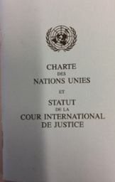

**PDF Document:** The UN Charter is the hallmark mandate and foundation document of the United Nations and the Statute of the International Court of Justice.

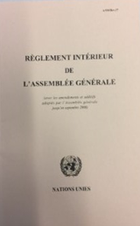

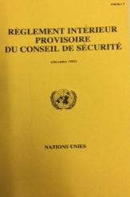**PDF Document:** The Rules of Procedure of the General Assembly.

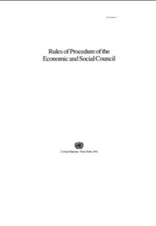

**PDF Document:** The Provisional Rules and Procedure of the Security Council.

**PDF Document:** The Rules and Procedure of the Economic and Social Council (ECOSOC).

**Linked Documents**

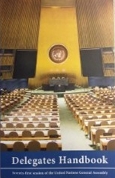

**Link:** The Delegates Handbook is the comprehensive “How To” guide to the UN for new Delegates. It can be found online at <https://www.un.int/pm/delegates-handbook> and is updated annually.

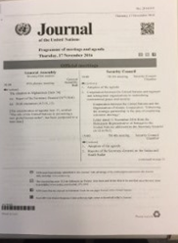

**Link:** The United Nations Journal is a document that lists all relevant briefings, courses and sessions occurring in the United Nations on a given day. It can be found at <http://www.un.org/en/sections/documents/journal-united-nations/> and is updated daily.



**Link:** The UN Bluebook is a directory of all UN Permanent Missions and their relevant staff members. It can be found at <https://protocol.un.org/dgacm/pls/site.nsf/BlueBook.xsp> and is updated biannually.